**W03 Project: Rafting Site - Planning Document**

1. **Logo:**

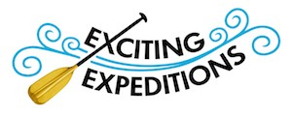

1. **Colors:**
   1. Primary color: #48DDFF
   2. Secondary color: #3CFDDD
   3. Accent 1 color: #C5DCB0
   4. Accent 2 color: #E2C2FF
2. **Typography:**
   * 1. Heading-front: Lobster
     2. Body: Roboto
3. **Color Palette**
   1. <https://coolors.co/48ddff-3cfddd-c5dcb0-e2c2ff>